Lab 5

D0011E

# Part 1

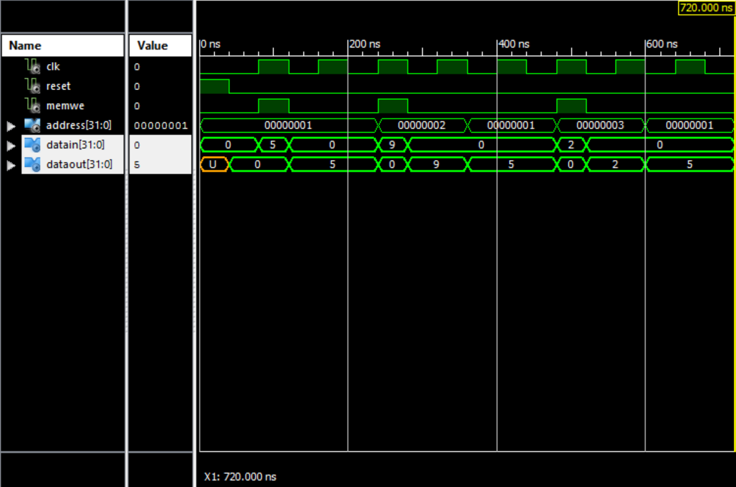

# Part 2

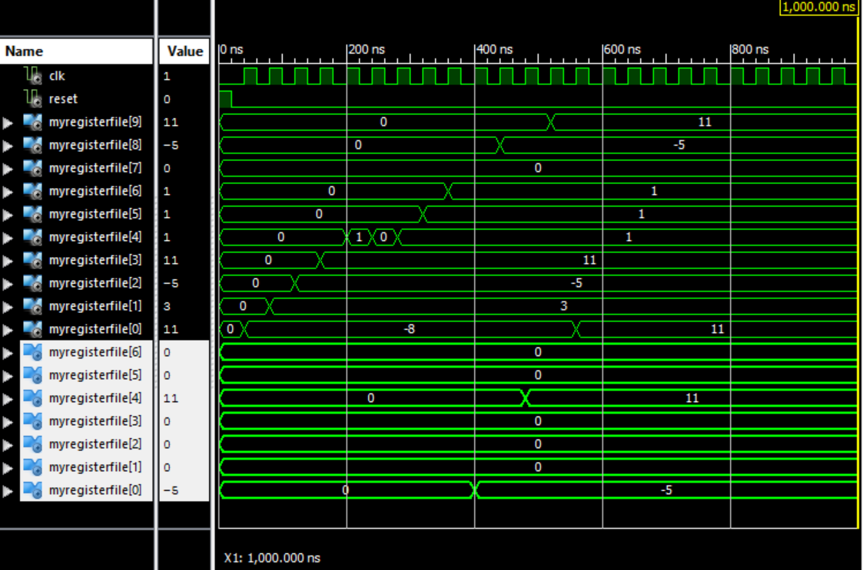

The marked registers are the ones in the data memory and the other registers are the registers in the register file.

# Part 3

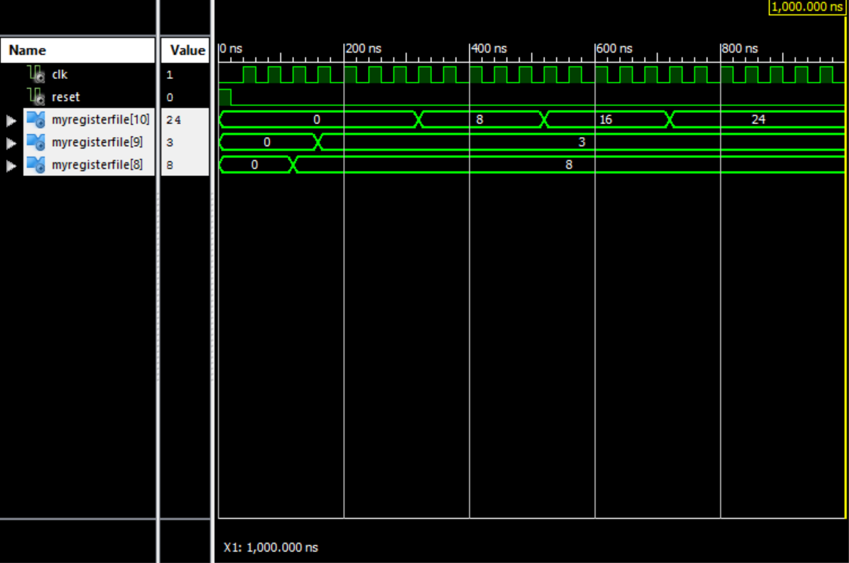

Where r8 and r9 contains the numbers to be multiplied and r10 contains the result of the multiplication.

# Part 4

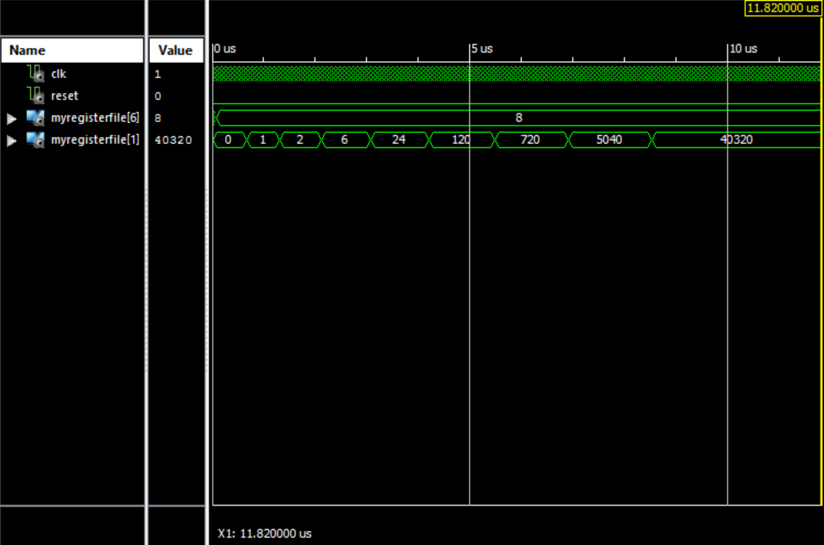

Where r6 contains the number and r1 contains the factorial of that number.